FINAL PROJECT DOCUMENTATION
Managing Sentry
A POINT-OF-SALE AND INVENTORY MANAGEMENT SYSTEM
Custom-built exclusively for Alekos' Corner General Merchandise

GROUP NUMBER  SWU - 09 | GROUP MEMBERS  Aldave, Resty S.  Bagahansol, Shan Lester S.  Llaguno, Clary Mae F.  Rama, John Wilfred Y. | DATE  October 2026

Table of Contents

Project Summary 3
System Use Cases 4
POS-01 Process Sales Transaction 4
INV-01 Manage Products and Inventory 7
INV-02 Manage Stock Adjustments and Restocking 9
CAP-01 Configure Starting Capital 10
VSR-01 View Sales Reports 12
POS-02 Manage Order History 14
Entity-Relationship Diagram 16
Relational Schema 18
Normalization Proof 21
Unnormalized Form (UNF) 21
First Normal Form (1NF) 23
Second Normal Form (2NF) 25
Third Normal Form (3NF) 27
System Architecture and Technology Stack 32
GitHub Repository 34
Deployed API 36

SECTION 01

Project Summary
What the system is, the problem it solves, and who it is for.

Overview
Managing Sentry is a point-of-sale and inventory management system custom-built exclusively for Alekos’ Corner General Merchandise. Staff process in-store cash sales through an Android POS interface, and each sale is recorded in the database while stock is updated in real time.

Problem Statement
A general merchandise store must record every sale and keep stock, expiration dates, and capital accurate. When these records are kept apart, stock counts drift from actual sales, expiring or low-stock items go unnoticed, and the owner has no single reliable view of sales performance.

Purpose and Objectives
The primary purpose of Managing Sentry is to give Alekos’ Corner General Merchandise a single system that records every cash sale accurately and keeps inventory up to date in real time.
1. To process in-store cash sales through the Android POS, including total and change computation.
2. To log every order and deduct stock in real time after each sale, with an audit record.
3. To let the administrator manage products, pricing, restocking, stock adjustments, and starting capital.
4. To let the administrator review sales reports and order history.

Target Users
User | Description | What They Do in the System
Administrator | Store administrator or manager | Manages products, restocking, stock adjustments, and capital; reviews sales reports and order history
Staff (Cashier) | Store employee at the counter | Looks up products on the Android POS, enters quantities and cash received, and completes sales
Customer | Shopper buying at the counter | Presents items and pays in cash; does not use the system directly

Scope and Limitations
Scope | Android POS cash sales, real-time stock deduction, order history, product and pricing management, restocking and stock adjustments with audit records, starting capital, and sales reports.
Limitations | No barcode scanner integration (manual product entry); cash only, with no payment gateways, digital wallets, cards, or split payments; no multi-tenant support; no e-commerce or online ordering.
SECTION 02

System Use Cases
What the system does, described from the user’s point of view.

UC-01 Process Sale Transaction
Use Case ID | POS-01
Use Case Name | Process Sales Transaction
Primary Actor | Staff (Cashier)
Secondary Actor(s) | Customer
Description | A staff member looks up items via the Android POS interface, calculates order totals, processes cash payments, logs the order in the database, and updates stock quantities in real time.
Trigger | Customer presents items at the counter for purchase.
Preconditions | Products must exist in the Product table with defined prices and positive Stock_Quantity. Staff must be logged in to the Android POS app.
Postconditions | An Order record and associated OrderItem records are created, Stock_Quantity is reduced in Product, and the status is logged in History.
Basic Flow | 1. Customer brings the items to the counter.  2. Staff opens the Android POS interface.  3. Staff searches for the product.  4. Staff selects the product.  5. System retrieves the product details.  6. System displays the product name.  7. System displays the retail price.  8. System displays the current available stock.  9. Staff enters the quantity to purchase.  10. System validates the requested quantity against the available stock.  11. System calculates the line subtotal.  12. System adds the selected product to the transaction.  13. Staff repeats the product selection process for additional items, if needed.  14. System calculates the total amount due.  15. Customer provides cash payment to the staff.  16. Staff enters the cash amount received into the Android POS.  17. System compares the amount tendered with the total amount due.  18. System calculates the change due.  19. System displays the calculated change.  20. System creates the Order record. An order contains one or more OrderItem line records.  21. System creates the OrderItem records, including the Cost_Snapshot and Price_Snapshot values that preserve historical accuracy.  22. System deducts the purchased quantity from the product stock.  23. System creates a stock adjustment record for the sale.  24. System records the audit details for the stock adjustment.  25. System creates the transaction History record with Order_Status set to “COMPLETED”.  26. System sets the order status to “COMPLETED”.  27. System displays the transaction confirmation.  28. Staff gives the calculated change to the customer.  29. Staff gives the purchased items to the customer.
Alternative Flow | 14a. If the customer decides to cancel the transaction before providing payment, the staff cancels the transaction on the Android POS. The system terminates the current transaction and creates no Order, OrderItem, stock adjustment, or COMPLETED History record. Product.Stock_Quantity is not deducted. The POS returns to the product selection or ready state, and the transaction ends without affecting inventory or sales records.
Exception Flow | 10a. If the requested quantity is greater than Stock_Quantity, the system displays an out-of-stock alert and prevents the product from being added to the transaction (stock_quantity may never fall below zero, and checkout is blocked). The staff adjusts the quantity to the available stock or removes the item. The flow resumes at step 9.  17a. If the amount tendered is less than the total amount due, the system detects it and the staff informs the customer of the remaining balance. The customer provides additional cash, and the flow resumes at step 16.
Include / Extend | None

Use Case Diagram
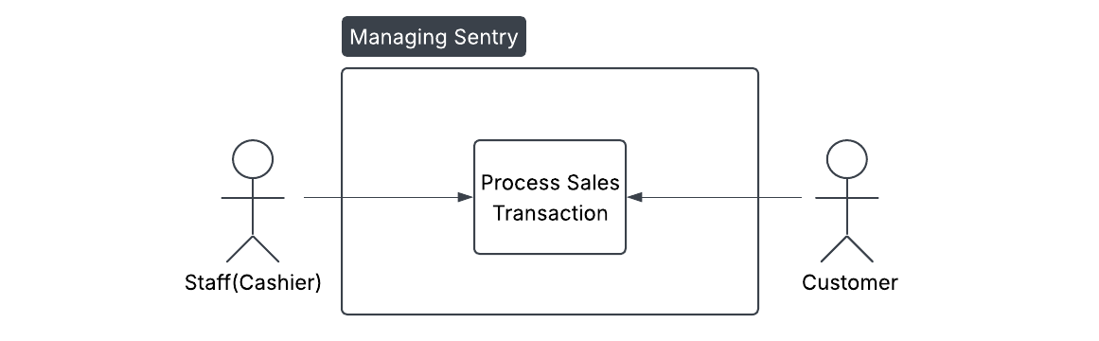
Figure 1. Process Sales Transaction use case diagram

INV-01 Manage Products and Inventory

Use Case Description
Use Case ID | INV-01
Use Case Name | Manage Products and Inventory
Primary Actor | Administrator
Secondary Actor(s) | None
Description | The administrator manages product information, pricing, stock quantities, expiration dates, and low-stock alert levels through the Managing Sentry system. The system validates and saves the updated product information for use in sales and inventory monitoring.
Trigger | The administrator needs to add, update, or maintain product and inventory information.
Preconditions | The administrator is logged in to the Managing Sentry system and has permission to manage products and inventory. The product must exist when performing an update.
Postconditions | Product information is successfully created or updated, including its pricing, stock quantity, expiration date, and low-stock alert level. The updated information is available for POS transactions and inventory monitoring.
Basic Flow | 1. The administrator opens product management.  2. The system retrieves the product records.  3. The system displays the product list.  4. The administrator selects an add or edit operation.  5. The administrator enters the product name.  6. The administrator enters the base cost.  7. The administrator enters the markup amount.  8. The administrator enters the retail price.  9. The administrator enters the stock quantity.  10. The administrator enters the expiration date.  11. The administrator enters the low-stock alert level.  12. The system validates the product information.  13. The system saves the product information.  14. The system displays a confirmation message.
Alternative Flow | None
Exception Flow | 12a. If the system detects invalid product information, it displays an error message. The administrator corrects the information, and the system validates the corrected information. The flow resumes at step 13.
Include / Extend | None

Use Case Diagram

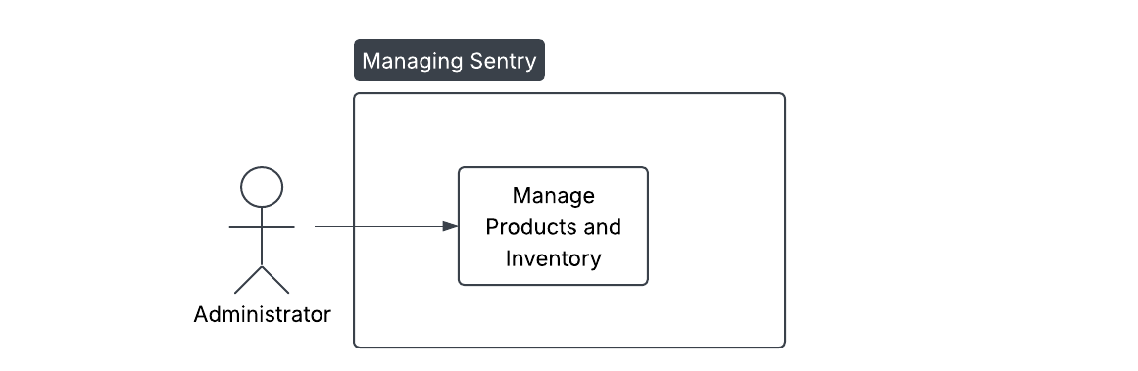
Figure 2. Manage Products and Inventory use case diagram

INV-02 Manage Stock Adjustments and Restocking

Use Case Description
Use Case ID | INV-02
Use Case Name | Manage Stock Adjustments and Restocking
Primary Actor | Administrator
Secondary Actor(s) | None
Description | The administrator records authorized inventory adjustments and restocking activities, updates product stock quantities, and maintains an audit record of the adjustment.
Trigger | The administrator needs to restock a product or correct an authorized inventory quantity.
Preconditions | The administrator is logged in to the system and has inventory-management permission. The affected product must exist.
Postconditions | The product stock quantity is updated and a Stock Adjustment record is created. The adjustment type, quantity, responsible user, audit notes, and transaction date are stored.
Basic Flow | 1. The administrator opens stock adjustment management.  2. The system displays the available products.  3. The administrator selects a product.  4. The administrator selects an adjustment type.  5. The administrator enters the quantity changed.  6. The administrator enters the unit cost.  7. The administrator enters audit notes.  8. The system validates the adjustment information.  9. The system updates the product stock.  10. The system creates the stock adjustment record.  11. The system records the responsible user.  12. The system records the transaction date.  13. The system displays the adjustment confirmation.
Alternative Flow | None
Exception Flow | 8a. If the entered quantity is invalid, the system rejects the stock adjustment. The user enters a valid quantity, and the system validates it again. The flow resumes at step 9.
Include / Extend | None

Use Case Diagram

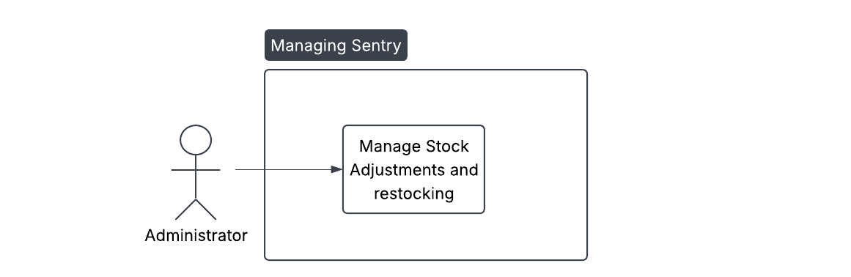
Figure 3. Manage Stock Adjustments and Restocking use case diagram

CAP-01 Configure Starting Capital

Use Case Description
Use Case ID | CAP-01
Use Case Name | Configure Starting Capital
Primary Actor | Administrator
Secondary Actor(s) | None
Description | The administrator establishes and maintains the store’s starting capital and current capital balance configuration used by Managing Sentry.
Trigger | The administrator needs to establish or update the store’s starting capital configuration.
Preconditions | The administrator is logged in to the system and has permission to manage capital configuration. The capital amount must be provided.
Postconditions | The starting capital and current balance are stored, and the date and time of the configuration update are recorded.
Basic Flow | 1. The administrator opens capital configuration.  2. The system retrieves the current configuration.  3. The system displays the current capital.  4. The administrator enters the starting capital.  5. The system validates the starting capital.  6. The system sets the current balance.  7. The system records the update time.  8. The system saves the configuration.  9. The system displays a confirmation.
Alternative Flow | None
Exception Flow | 5a. If the entered capital amount is invalid, the system rejects it and the existing capital configuration remains unchanged.
Include / Extend | None

Use Case Diagram
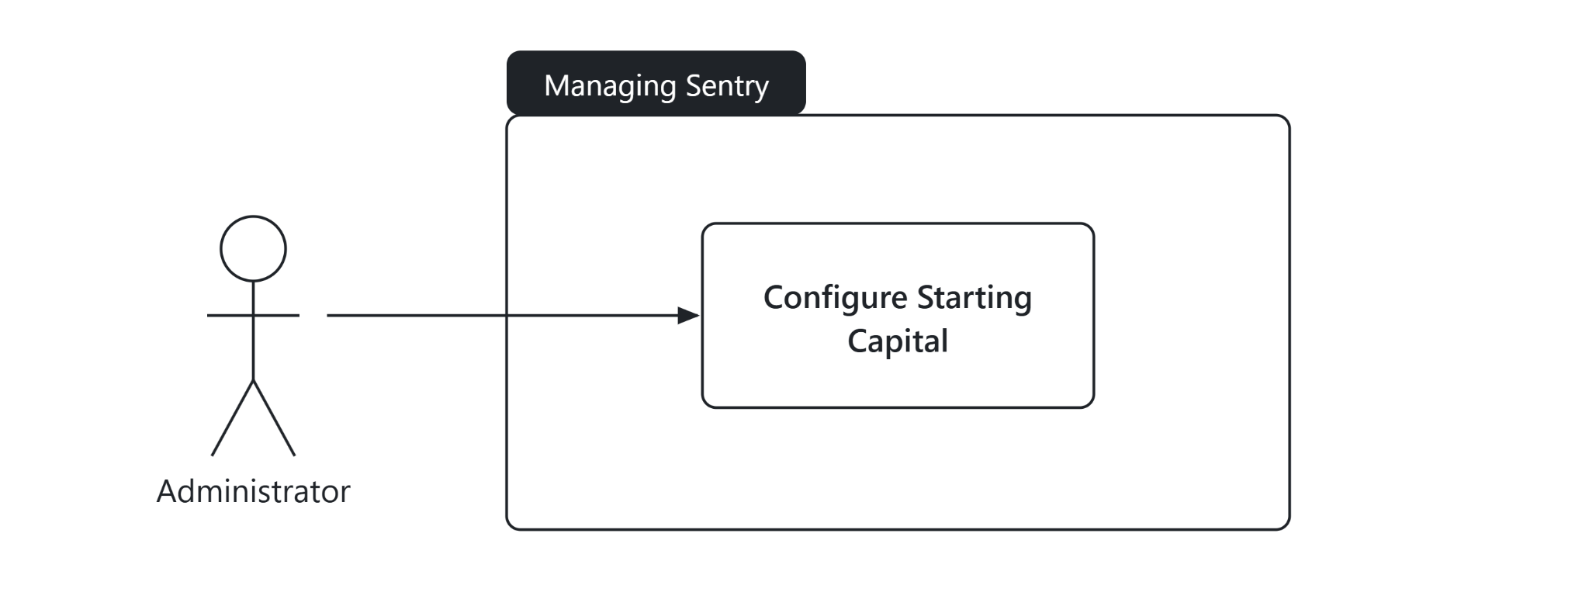

Figure 4. Configure Starting Capital use case diagram

VSR-01 View Sales Reports

Use Case Description
Use Case ID | VSR-01
Use Case Name | View Sales Reports
Primary Actor | Administrator
Secondary Actor(s) | None
Description | The administrator retrieves and reviews recorded sales information to monitor store transactions and support business decision-making.
Trigger | The administrator needs to review recorded sales information.
Preconditions | The administrator is logged in to the system, and sales records are available in the database.
Postconditions | The requested sales information is displayed to the administrator. Existing transaction records remain unchanged.
Basic Flow | 1. The administrator opens the sales report module.  2. The system retrieves the order records.  3. The system retrieves the order-item records.  4. The system retrieves the related product information.  5. The system processes the retrieved information.  6. The system generates the sales report.  7. The system displays the sales report.  8. The administrator reviews the report.
Alternative Flow | None
Exception Flow | 2a. If the system finds no matching transactions, it displays a no-records message without modifying existing data. The administrator changes the report criteria, and the flow resumes at step 2.
Include / Extend | None

Use Case Diagram
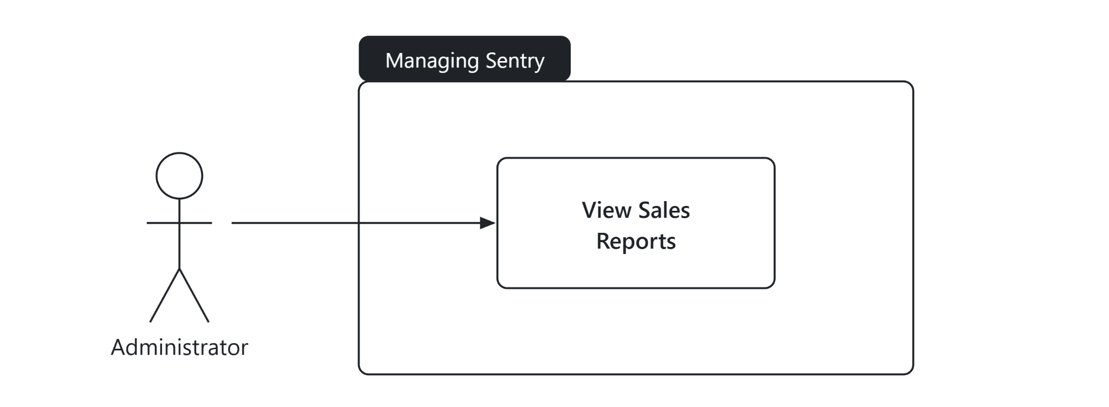

Figure 5. View Sales Reports use case diagram

POS-02 Manage Order History

Use Case Description
Use Case ID | POS-02
Use Case Name | Manage Order History
Primary Actor | Administrator
Secondary Actor(s) | None
Description | The administrator reviews recorded orders and their corresponding transaction statuses to monitor COMPLETED transactions and maintain visibility of order history.
Trigger | The administrator needs to review a previous order or transaction status.
Preconditions | The administrator is logged in to the system. Order records exist for the requested transaction, and history records are available for COMPLETED transactions.
Postconditions | The selected order information and its corresponding transaction status are displayed. No existing transaction data is modified.
Basic Flow | 1. The administrator opens order history.  2. The system retrieves the orders.  3. The system retrieves the history records.  4. The system matches the history records to the orders.  5. The system displays the order history.  6. The administrator selects an order.  7. The system retrieves the selected order.  8. The system retrieves its status history.  9. The system displays the transaction details.
Alternative Flow | None
Exception Flow | 3a. If a history record is unavailable, the system does not create false history information and preserves the existing order data.
Include / Extend | None

Use Case Diagram

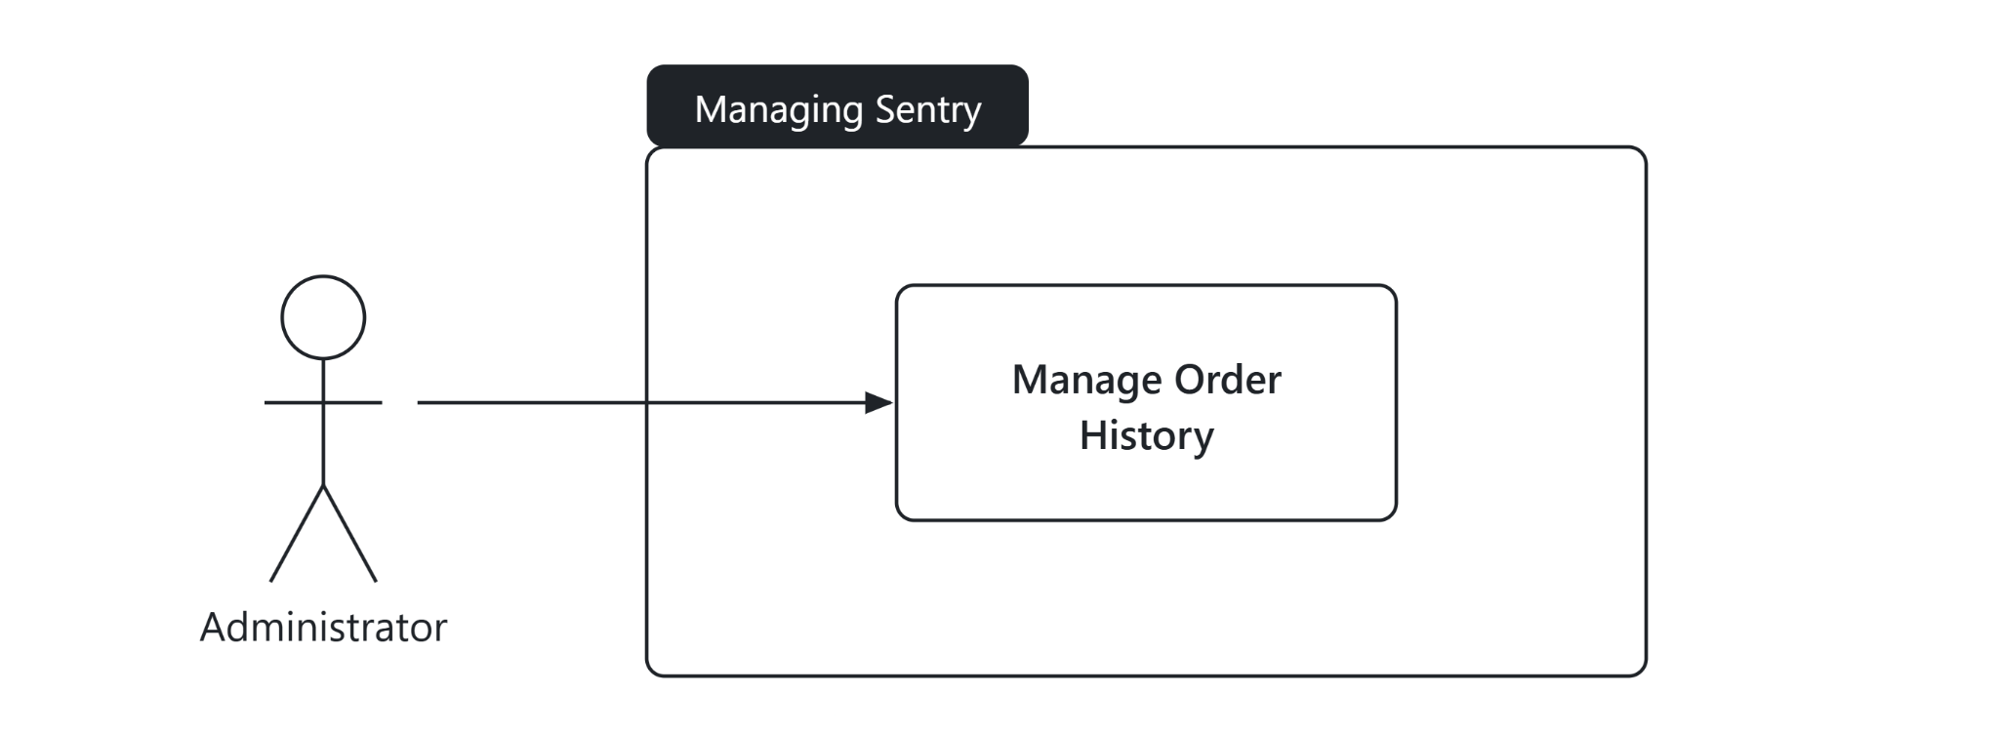
Figure 6. Manage Order History use case diagram

SECTION 03

Entity-Relationship Diagram
The entities, their attributes, and how they relate.
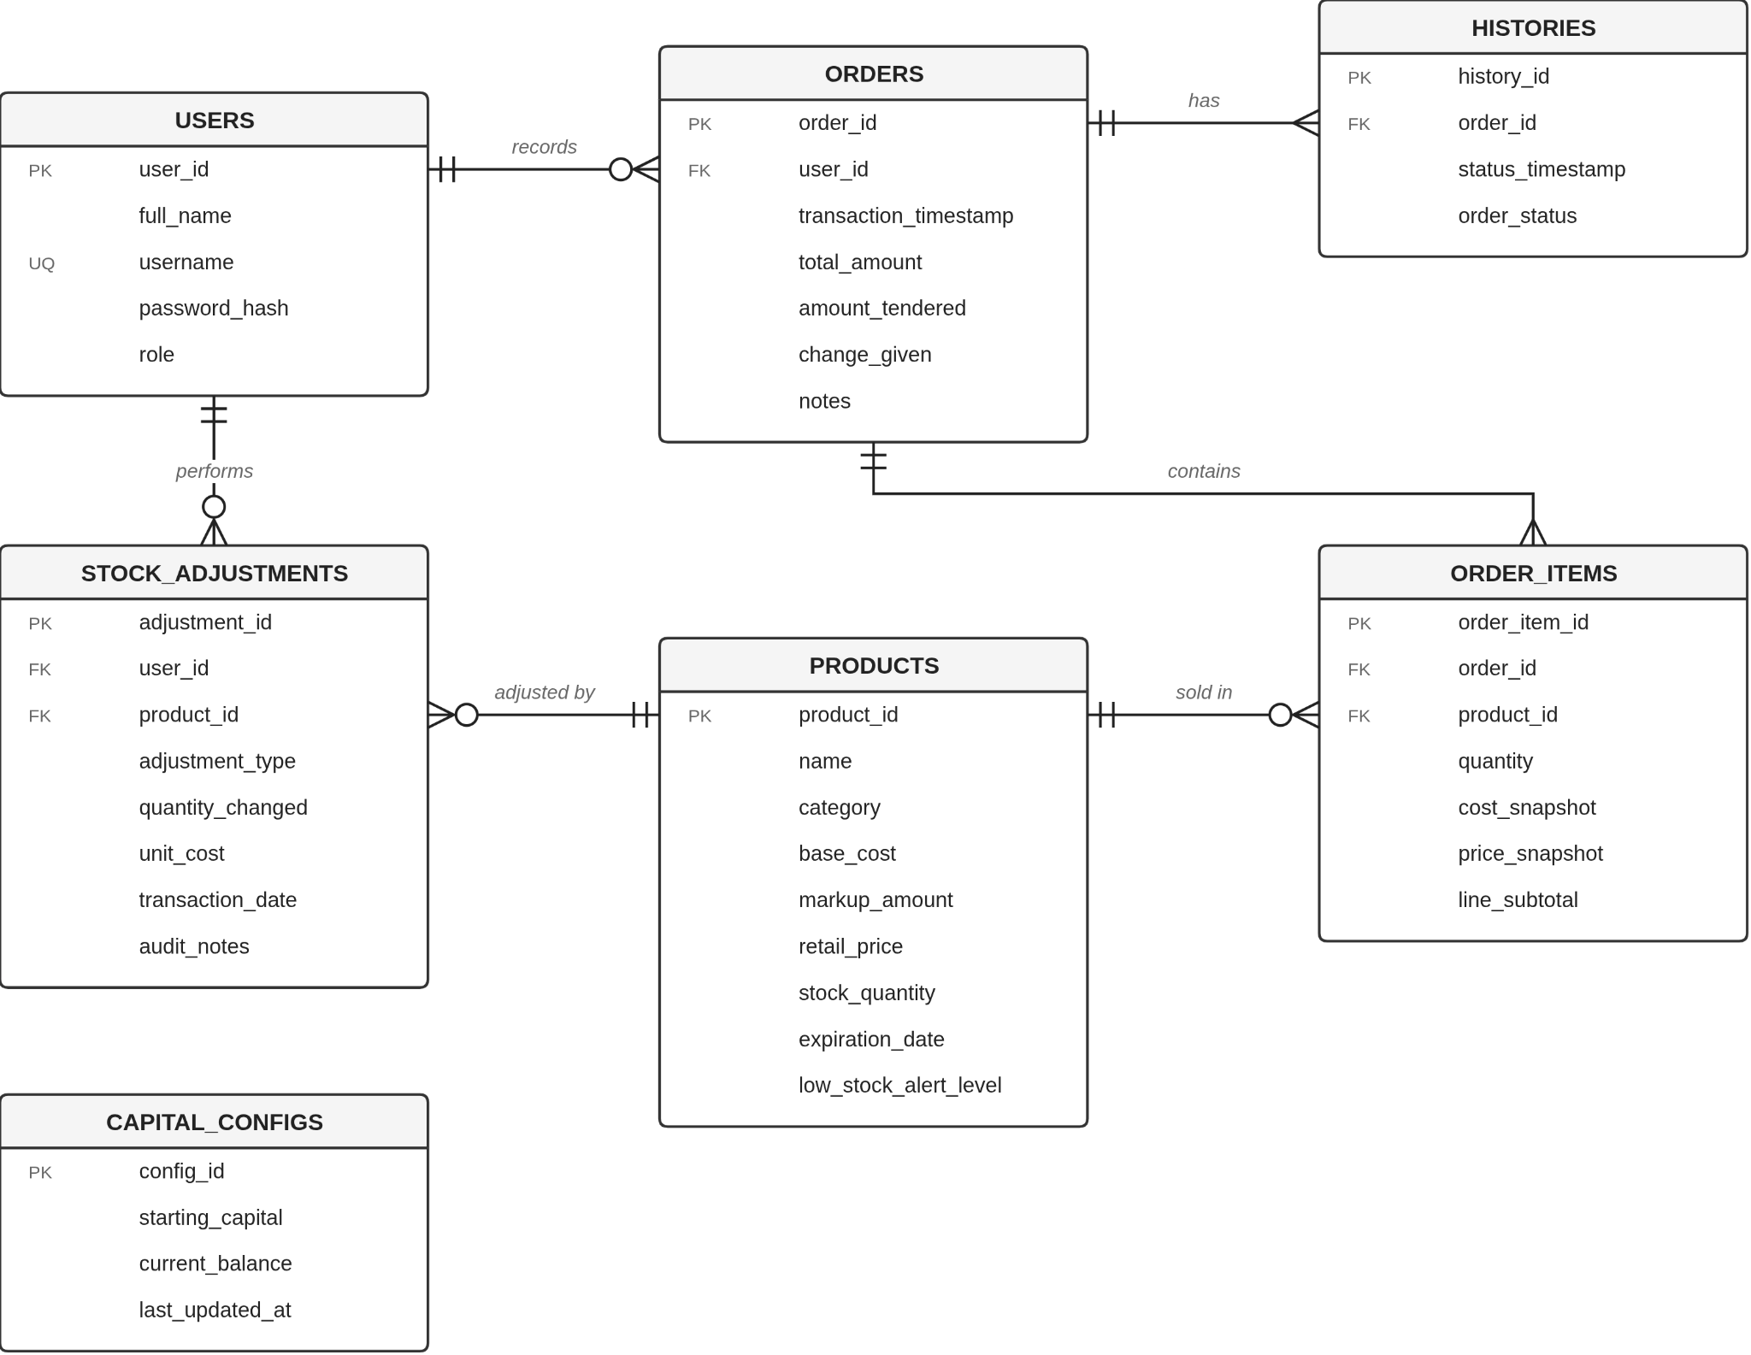
Figure 2. Entity-Relationship Diagram of Managing Sentry

Relationship Summary
Entity | Relationship | Related Entity | Cardinality | Business Rule
users | records | orders | 1 : N | A user records zero or more orders; each order is recorded by exactly one user.
orders | contains | order_items | 1 : N | An order contains one or more order items; each item belongs to exactly one order.
products | sold in | order_items | 1 : N | A product appears in zero or more order items; each item refers to exactly one product. order_items resolves the many-to-many relationship between orders and products.
orders | has | histories | 1 : N | An order has one or more status history records; each history record belongs to exactly one order.
users | performs | stock_adjustments | 1 : N | A user performs zero or more stock adjustments; each adjustment is made by exactly one user.
products | adjusted by | stock_adjustments | 1 : N | A product has zero or more stock adjustments; each adjustment refers to exactly one product.
capital_configs | — | — | None | Standalone configuration table that stores the store’s starting capital and current balance; it has no foreign key relationship in the ERD.

SECTION 04

Relational Schema
The tables, keys, and data types of the database.

Schema Notation
Legend primary_key = Primary Key foreign_key* = Foreign Key
users (user_id, full_name, username, password_hash, role)
capital_configs (config_id, starting_capital, current_balance, last_updated_at)
products (product_id, name, category, base_cost, markup_amount, retail_price, stock_quantity, expiration_date, low_stock_alert_level)
orders (order_id, user_id*, transaction_timestamp, total_amount, amount_tendered, change_given, notes)
order_items (order_item_id, order_id*, product_id*, quantity, cost_snapshot, price_snapshot, line_subtotal)
stock_adjustments (adjustment_id, product_id*, user_id*, adjustment_type, quantity_changed, unit_cost, transaction_date, audit_notes)
histories (history_id, order_id*, status_timestamp, order_status)

Data Dictionary
users
Attribute | Data Type | Key | Constraints
user_id | INT | PK | NOT NULL, AUTO_INCREMENT
full_name | VARCHAR(100) |  | NOT NULL
username | VARCHAR(50) |  | NOT NULL, UNIQUE
password_hash | VARCHAR(255) |  | NOT NULL
role | ENUM('Admin', 'Manager', 'Staff') |  | NOT NULL

capital_configs
Attribute | Data Type | Key | Constraints
config_id | INT | PK | NOT NULL, AUTO_INCREMENT
starting_capital | DECIMAL(12,2) |  | NOT NULL
current_balance | DECIMAL(12,2) |  | NOT NULL
last_updated_at | DATETIME |  | NOT NULL
products
Attribute | Data Type | Key | Constraints
product_id | INT | PK | NOT NULL, AUTO_INCREMENT
name | VARCHAR(100) |  | NOT NULL
category | VARCHAR(50) |  | NOT NULL
base_cost | DECIMAL(10,2) |  | NOT NULL
markup_amount | DECIMAL(10,2) |  | NOT NULL
retail_price | DECIMAL(10,2) |  | NOT NULL
stock_quantity | INT |  | NOT NULL
expiration_date | DATE |  | NULL
low_stock_alert_level | INT |  | NOT NULL
orders
Attribute | Data Type | Key | Constraints
order_id | INT | PK | NOT NULL, AUTO_INCREMENT
user_id | INT | FK | NOT NULL, REFERENCES users(user_id)
transaction_timestamp | DATETIME |  | NOT NULL
total_amount | DECIMAL(10,2) |  | NOT NULL
amount_tendered | DECIMAL(10,2) |  | NOT NULL
change_given | DECIMAL(10,2) |  | NOT NULL
notes | TEXT |  | NULL
order_items
Attribute | Data Type | Key | Constraints
order_item_id | INT | PK | NOT NULL, AUTO_INCREMENT
order_id | INT | FK | NOT NULL, REFERENCES orders(order_id)
product_id | INT | FK | NOT NULL, REFERENCES products(product_id)  (composite UNIQUE: order_id, product_id)
quantity | INT |  | NOT NULL, CHECK (quantity > 0)
cost_snapshot | DECIMAL(10,2) |  | NOT NULL
price_snapshot | DECIMAL(10,2) |  | NOT NULL
line_subtotal | DECIMAL(10,2) |  | NOT NULL
stock_adjustments
Attribute | Data Type | Key | Constraints
adjustment_id | INT | PK | NOT NULL, AUTO_INCREMENT
product_id | INT | FK | NOT NULL, REFERENCES products(product_id)
user_id | INT | FK | NOT NULL, REFERENCES users(user_id)
adjustment_type | VARCHAR(30) |  | NOT NULL (e.g., RESTOCK, EXPIRED, DAMAGED, STOCK IN)
quantity_changed | INT |  | NOT NULL
unit_cost | DECIMAL(10,2) |  | NULL
transaction_date | DATETIME |  | NOT NULL
audit_notes | VARCHAR(255) |  | NULL
histories
Attribute | Data Type | Key | Constraints
history_id | INT | PK | NOT NULL, AUTO_INCREMENT
order_id | INT | FK | NOT NULL, REFERENCES orders(order_id)
status_timestamp | DATETIME |  | NOT NULL
order_status | VARCHAR(20) |  | NOT NULL, DEFAULT 'COMPLETED'
SECTION 05

Normalization Proof
From Unnormalized Form to Third Normal Form, with justification.

Unnormalized Form (UNF)
RULE
A relation is unnormalized when it contains repeating groups or attributes that hold more than one value.
SOURCE DOCUMENTS
Sales transaction (order) record, product catalog record, stock adjustment log, order status history, and store capital configuration.
RELATION
sales_records (order_id, transaction_timestamp, total_amount, amount_tendered, change_given, notes, user_id, full_name, username, password_hash, role, config_id, starting_capital, current_balance, last_updated_at, {products_purchased}, {stock_adjustments}, {order_history})
Braces { } enclose the repeating groups.
SAMPLE DATA
Attribute Name | Sample Value
order_id | 1
transaction_timestamp | 2026-03-01 10:15:00
total_amount | 130.00
amount_tendered | 200.00
change_given | 70.00
notes | NULL
user_id | 1
full_name | John Smith
username | john_admin
password_hash | 2b12eImigU...
role | Admin
config_id | 1
starting_capital | 10000.00
current_balance | 10130.00
last_updated_at | 2026-03-01 08:00:00
products_purchased | [1: Coffee (Category: Beverages, Qty: 2, Cost: 35.00, Markup: 15.00, Price: 50.00, Stock: 48, Exp: 2026-12-31, LowAlert: 10), 2: Bread (Category: Bakery, Qty: 1, Cost: 20.00, Markup: 10.00, Price: 30.00, Stock: 29, Exp: 2026-03-05, LowAlert: 5)]
stock_adjustments | [Adj_ID: 1, Product: 1, User: 1, Type: RESTOCK, Qty: 50, UnitCost: 35.00, Date: 2026-03-01 08:00:00, Notes: Initial stock setup]
order_history | [Hist_ID: 1, Order: 1, Time: 2026-03-01 10:15:00, Status: COMPLETED]
FUNCTIONAL DEPENDENCIES
Determinant (Left Side) | Dependent Attributes (Right Side) | Dependency Scope
order_id | transaction_timestamp, total_amount, amount_tendered, change_given, notes, user_id, full_name, username, password_hash, role, config_id, starting_capital, current_balance, last_updated_at | Order header attributes
product_id | name, category, base_cost, markup_amount, retail_price, stock_quantity, expiration_date, low_stock_alert_level | Product catalog attributes
(order_id, product_id) | quantity, cost_snapshot, price_snapshot, line_subtotal | Order line item attributes
config_id | starting_capital, current_balance, last_updated_at | System capital configuration
JUSTIFICATION
sales_records is in UNF because a single order record holds multi-valued repeating groups: products_purchased lists two products (product_id 1 Coffee and product_id 2 Bread) in one record, and stock_adjustments and order_history carry nested logs. The record also mixes system configuration settings (starting_capital, current_balance, last_updated_at) with order data. The category attribute is included inside each product entry from the start to keep the schema consistent.

First Normal Form (1NF)
RULE
A relation is in 1NF when it has no repeating groups, every attribute holds a single atomic value, and a primary key is identified.
RELATION
sales_records (order_id, product_id, transaction_timestamp, name, category, base_cost, markup_amount, retail_price, quantity, cost_snapshot, price_snapshot, line_subtotal, total_amount, amount_tendered, change_given, notes, stock_quantity, expiration_date, low_stock_alert_level, user_id, full_name, username, password_hash, role, config_id, starting_capital, current_balance, last_updated_at)
PRIMARY KEY
Composite primary key {order_id (PK, FK), product_id (PK, FK)}. (PK) marks a component of the primary key and (FK) a foreign key that references orders and products once the relation is decomposed.
SAMPLE DATA
The table is split into three parts for readability. order_id and product_id are repeated in each part as reference keys.
Part 1 of 3 — Order and product pricing attributes
order_​id (PK, FK) | product_​id (PK, FK) | transaction_​timestamp | name | category | base_​cost | markup_​amount | retail_​price | quantity | cost_​snapshot | price_​snapshot
1 | 1 | 2026-03-01 10:15:00 | Coffee | Beverages | 35.00 | 15.00 | 50.00 | 2 | 35.00 | 50.00
1 | 2 | 2026-03-01 10:15:00 | Bread | Bakery | 20.00 | 10.00 | 30.00 | 1 | 20.00 | 30.00
Part 2 of 3 — Transaction totals and stock attributes
order_​id (PK, FK) | product_​id (PK, FK) | line_​subtotal | total_​amount | amount_​tendered | change_​given | stock_​quantity | expiration_​date | low_​stock_​alert_​level | user_​id | notes
1 | 1 | 100.00 | 130.00 | 200.00 | 70.00 | 48 | 2026-12-31 | 10 | 1 | NULL
1 | 2 | 30.00 | 130.00 | 200.00 | 70.00 | 29 | 2026-03-05 | 5 | 1 | NULL
Part 3 of 3 — User and capital configuration attributes
order_​id (PK, FK) | product_​id (PK, FK) | full_​name | username | password_​hash | role | config_​id | starting_​capital | current_​balance | last_​updated_​at
1 | 1 | John Smith | john_​admin | 2b12eImigU... | Admin | 1 | 10000.00 | 10130.00 | 2026-03-01 08:00:00
1 | 2 | John Smith | john_​admin | 2b12eImigU... | Admin | 1 | 10000.00 | 10130.00 | 2026-03-01 08:00:00

FUNCTIONAL DEPENDENCIES
FD1 (order_id, product_id) → quantity, cost_snapshot, price_snapshot, line_subtotal — full dependency; depends on the whole composite key
FD2 product_id → name, category, base_cost, markup_amount, retail_price, stock_quantity, expiration_date, low_stock_alert_level — partial dependency; violates 2NF
FD3 order_id → transaction_timestamp, total_amount, amount_tendered, change_given, notes, user_id, full_name, username, password_hash, role, config_id, starting_capital — partial dependency; violates 2NF
JUSTIFICATION
The repeating group was unrolled into flat atomic rows, giving one row per product purchased in an order. order_id alone cannot be the primary key because order_id 1 appears in two rows (once for product_id 1 and once for product_id 2), so it would not identify a row. The composite key {order_id, product_id} identifies each order line (order_id 1 + product_id 1 and order_id 1 + product_id 2).
Because the key is composite, every non-key attribute must depend on both parts of it to satisfy 2NF. Product attributes depend only on product_id, and order header attributes depend only on order_id. Both are partial dependencies, and both are removed in 2NF by moving each set of attributes into its own relation (products and orders).

Second Normal Form (2NF)
RULE
A relation is in 2NF when it is in 1NF and every non-key attribute depends on the whole primary key, with no partial dependencies.
PARTIAL DEPENDENCIES FOUND
FD2 and FD3. Product attributes depend on product_id alone, and order header attributes depend on order_id alone. Each is only part of the composite key {order_id, product_id}.
RESULTING RELATIONS
products (product_id, name, category, base_cost, markup_amount, retail_price, stock_quantity, expiration_date, low_stock_alert_level)
orders (order_id, user_id, config_id, full_name, username, password_hash, role, transaction_timestamp, total_amount, amount_tendered, change_given, notes, starting_capital)
order_items (order_item_id, order_id*, product_id*, quantity, cost_snapshot, price_snapshot, line_subtotal)
SAMPLE DATA
products
product_​id (PK) | name | category | base_​cost | markup_​amount | retail_​price | stock_​quantity | expiration_​date | low_​stock_​alert_​level
1 | Coffee | Beverages | 35.00 | 15.00 | 50.00 | 48 | 2026-12-31 | 10
2 | Bread | Bakery | 20.00 | 10.00 | 30.00 | 29 | 2026-03-05 | 5
orders (part 1 of 2)
order_​id (PK) | user_​id | config_​id | full_​name | username | password_​hash
1 | 1 | 1 | John Smith | john_​admin | 2b12eImigU...
orders (part 2 of 2)
order_​id (PK) | role | transaction_​timestamp | total_​amount | amount_​tendered | change_​given | starting_​capital | notes
1 | Admin | 2026-03-01 10:15:00 | 130.00 | 200.00 | 70.00 | 10000.00 | NULL
order_items
order_​item_​id (PK) | order_​id (FK) | product_​id (FK) | quantity | cost_​snapshot | price_​snapshot | line_​subtotal
1 | 1 | 1 | 2 | 35.00 | 50.00 | 100.00
2 | 1 | 2 | 1 | 20.00 | 30.00 | 30.00

DEPENDENCIES REMAINING FOR 3NF
Location | Dependency Identified | Classification | Action Required for 3NF
orders table | user_id → full_name, username, password_hash, role | Transitive dependency (order_id → user_id → full_name) | Extract to users table
orders table | config_id → starting_capital, current_balance, last_updated_at | Business configuration dependency | Extract to capital_configs table (standalone store-level table; no foreign key in orders)
JUSTIFICATION
Attributes that depend only on product_id were moved to products, and attributes that depend only on order_id were moved to orders. order_items keeps the attributes that depend on the order line, and uses a surrogate key order_item_id with order_id and product_id as foreign keys. No partial dependency remains.
starting_capital was removed from orders because it does not describe a property of the order itself. It describes the store’s cash configuration, which exists independently of any single order. The real determinant is config_id → starting_capital, current_balance, last_updated_at. Because starting_capital depends on config_id rather than directly on the primary key order_id, it is a transitive or business dependency and is extracted into its own relation, capital_configs, in 3NF, as a standalone store-level table (orders does not reference it).

Third Normal Form (3NF)
RULE
A relation is in 3NF when it is in 2NF and no non-key attribute depends on another non-key attribute, with no transitive dependencies.
TRANSITIVE DEPENDENCIES FOUND
order_id → user_id → full_name, username, password_hash, role
order_id → config_id → starting_capital, current_balance, last_updated_at
FINAL RELATIONS
users (user_id, full_name, username, password_hash, role)
capital_configs (config_id, starting_capital, current_balance, last_updated_at)
products (product_id, name, category, base_cost, markup_amount, retail_price, stock_quantity, expiration_date, low_stock_alert_level)
orders (order_id, user_id*, transaction_timestamp, total_amount, amount_tendered, change_given, notes)
order_items (order_item_id, order_id*, product_id*, quantity, cost_snapshot, price_snapshot, line_subtotal)
stock_adjustments (adjustment_id, product_id*, user_id*, adjustment_type, quantity_changed, unit_cost, transaction_date, audit_notes)
histories (history_id, order_id*, status_timestamp, order_status)
SAMPLE DATA
users
user_id (PK) | full_name | username | password_hash | role
1 | John Smith | john_admin | 2b12eImigU... | Admin
2 | Jack Davis | jack_cashier | 2b12kP9qL... | Staff
capital_configs
config_id (PK) | starting_capital | current_balance | last_updated_at
1 | 10000.00 | 10130.00 | 2026-03-01 08:00:00
products
product_​id (PK) | name | category | base_​cost | markup_​amount | retail_​price | stock_​quantity | expiration_​date | low_​stock_​alert_​level
1 | Coffee | Beverages | 35.00 | 15.00 | 50.00 | 48 | 2026-12-31 | 10
2 | Bread | Bakery | 20.00 | 10.00 | 30.00 | 29 | 2026-03-05 | 5

orders
order_​id (PK) | user_​id (FK) | transaction_​timestamp | total_​amount | amount_​tendered | change_​given | notes
1 | 1 | 2026-03-01 10:15:00 | 130.00 | 200.00 | 70.00 | NULL
order_items
order_​item_​id (PK) | order_​id (FK) | product_​id (FK) | quantity | cost_​snapshot | price_​snapshot | line_​subtotal
1 | 1 | 1 | 2 | 35.00 | 50.00 | 100.00
2 | 1 | 2 | 1 | 20.00 | 30.00 | 30.00
stock_adjustments
adjustment_​id (PK) | product_​id (FK) | user_​id (FK) | adjustment_​type | quantity_​changed | unit_​cost | transaction_​date | audit_​notes
1 | 1 | 1 | RESTOCK | 50 | 35.00 | 2026-03-01 08:00:00 | Initial stock setup
histories
history_id (PK) | order_id (FK) | status_timestamp | order_status
1 | 1 | 2026-03-01 10:15:00 | COMPLETED
JUSTIFICATION
Transitive and non-key dependencies were removed so that every non-key attribute depends only on the primary key. User details were moved to users, and capital configuration was moved to capital_configs, leaving user_id in orders as a foreign key, while capital_configs stays a standalone store-level table. Every non-key attribute now depends on the key, the whole key, and nothing but the key. These seven relations are in 3NF.

Explicit 3NF Verification
Each final relation is verified below, confirming that every non-key attribute depends only on the primary key.
Relation Name | Primary Key | Direct Functional Dependency Statement | Transitive / Partial Dependencies Present? | 3NF Status
users | user_id | user_id → full_name, username, password_hash, role | None | Satisfied
capital_configs | config_id | config_id → starting_capital, current_balance, last_updated_at | None | Satisfied
products | product_id | product_id → name, category, base_cost, markup_amount, retail_price, stock_quantity, expiration_date, low_stock_alert_level | None | Satisfied
orders | order_id | order_id → user_id, transaction_timestamp, total_amount, amount_tendered, change_given, notes | None | Satisfied
order_items | order_item_id | order_item_id → order_id, product_id, quantity, cost_snapshot, price_snapshot, line_subtotal | None | Satisfied
stock_adjustments | adjustment_id | adjustment_id → product_id, user_id, adjustment_type, quantity_changed, unit_cost, transaction_date, audit_notes | None | Satisfied
histories | history_id | history_id → order_id, status_timestamp, order_status | None | Satisfied

Lossless-Join Proof
To prove that the decomposition from 1NF into 3NF is lossless, natural joins are executed across orders, order_items, and products for order_id 1.
RECONSTRUCTION CHAIN
order_id 1 → orders → order_items → products. Joining orders with order_items on order_id, then joining the result with products on product_id, must recreate the complete original order information with no missing or duplicated rows.
The complete UNF record is losslessly reconstructed through the dependency paths orders → order_items → products, orders → users, and capital_configs (a standalone store-level table, read directly by config_id and not joined per order). stock_adjustments and histories derive cleanly from the log arrays present in the initial UNF state. Each decomposition keeps the determinant as a key or foreign key, so no original information is lost and no spurious tuples are generated.
A surrogate order_item_id is introduced in 2NF and kept in 3NF as the primary key for each physical order line. It simplifies foreign key references from other tables, such as future returns, discounts, or line-level adjustments. The composite key {order_id, product_id} remains a valid candidate key because it still identifies a product within an order, and it can be enforced with a UNIQUE constraint.
RECONSTRUCTED ORDER DETAIL FOR ORDER_ID 1
• product_id 1 Coffee (Beverages) — Qty 2 × Price ₱50.00 = Subtotal ₱100.00
• product_id 2 Bread (Bakery) — Qty 1 × Price ₱30.00 = Subtotal ₱30.00
• Order Total = ₱100.00 + ₱30.00 = ₱130.00, matching orders.total_amount for order_id 1 exactly.
NATURAL JOIN STEP 1: orders ⋈ order_items ON order_id
Part 1 of 2 — order attributes
order_​id | user_​id | transaction_​timestamp | total_​amount | amount_​tendered | change_​given | notes
1 | 1 | 2026-03-01 10:15:00 | 130.00 | 200.00 | 70.00 | NULL
1 | 1 | 2026-03-01 10:15:00 | 130.00 | 200.00 | 70.00 | NULL
Part 2 of 2 — order item attributes
order_​id | order_​item_​id | product_​id | quantity | cost_​snapshot | price_​snapshot | line_​subtotal
1 | 1 | 1 | 2 | 35.00 | 50.00 | 100.00
1 | 2 | 2 | 1 | 20.00 | 30.00 | 30.00
NATURAL JOIN STEP 2: Temp1 ⋈ products ON product_id
order_​id | product_​id | transaction_​timestamp | name | category | quantity | retail_​price | line_​subtotal | total_​amount | user_​id
1 | 1 | 2026-03-01 10:15:00 | Coffee | Beverages | 2 | 50.00 | 100.00 | 130.00 | 1
1 | 2 | 2026-03-01 10:15:00 | Bread | Bakery | 1 | 30.00 | 30.00 | 130.00 | 1
FORMAL LOSSLESS PROOF VERIFICATION
Evaluation Parameter | Mathematical Condition | Result / Verification
Intersection attribute | R1 ∩ R2 = {order_id} | Common joining key across orders and order_items
Key functional dependency | R1 ∩ R2 → R1 | order_id is a superkey of the orders relation
Tuple loss verification | Count(Reconstructed) = 2 | Exactly 2 rows returned, matching the original 1NF record count
Spurious tuple check | Spurious Rows = 0 | No phantom or extraneous rows generated
Data integrity outcome | Line 1: 2 × 50 = 100; Line 2: 1 × 30 = 30; Total: 130.00 | Lossless join proven

SECTION 06

System Architecture and Technology Stack
How the parts of the system connect, and the tools used to build it.
Architecture Diagram
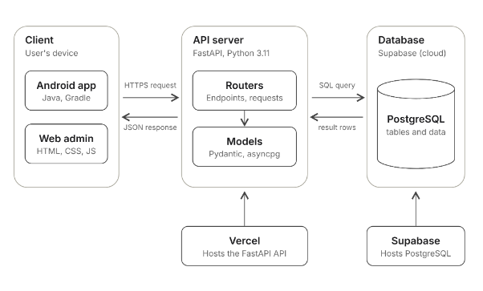
Figure 5. System architecture of Managing Sentry
Architecture Description
Managing Sentry follows a three-tier client-server architecture. A client, either the Android POS app or the web admin portal, sends an HTTPS request to the REST API. The API is a FastAPI backend (Python) hosted on Vercel. An earlier PHP prototype remains in the repository but is no longer used. The routers receive the request, validate it with Pydantic models, and apply the store’s rules, such as computing sale totals and change and updating stock after a checkout. The data layer uses asyncpg to read and write records in the PostgreSQL database hosted on Supabase, and the API returns the result to the client as JSON.
Technology Stack
Layer | Technology | Role in the System
Client | Android app (Java, Android SDK, Gradle), Retrofit; web admin portal (HTML5, CSS3, JavaScript) | Sends requests to the API and displays the responses, such as the cart, receipts, inventory, history, and the dashboard
Local storage | SQLite | Stores transactions offline on the Android app and syncs them when the connection returns
Backend | Python 3.11, FastAPI, Uvicorn | Defines the endpoints and applies the business rules, such as sale totals, change, and stock updates
Data access | asyncpg, Pydantic | Runs SQL queries on the database and validates request and response data
Database | PostgreSQL (Supabase) | Stores products, stock, sales transactions, stock adjustments, order history, and user accounts
Hosting | Vercel (API), Supabase (database) | Runs the live FastAPI API and the database
Version control | Git, GitHub | Tracks changes to the project
Tools | Android Studio, VS Code, pgAdmin, Figma | Used for coding, database management, and UI design

SECTION 07

GitHub Repository
Where the source code and database scripts live.
Repository URL | https://github.com/serious-capybara/managing-sentry
Visibility | Public
Default Branch | main

Repository Contents
Item | Location | Description
README | /README.md | System overview, tech stack, architecture, and step-by-step setup and run instructions
Contributing guide | /CONTRIBUTING.md | Branching strategy, commit and push rules, and pull request guidelines
Android app source code | /app | Android POS app (Java, Gradle) with the dashboard, products, and history screens, plus phone and tablet layouts
Web portal source code | /web | Web admin portal (HTML, CSS, JavaScript) that calls the API
Legacy PHP backend | /backend | Legacy PHP 8.2 prototype (endpoint handlers, database configuration, and core utilities) that has been replaced by the FastAPI backend and is no longer used
FastAPI backend | /backend-fastapi | Python FastAPI API with routers, Pydantic models, database connection, and security configuration
Database scripts | /db | Supabase schema and seed data (Managing_Sentry_rebuild.sql), which creates the tables and loads the existing records
Environment sample | /backend-fastapi/.env.example | Required environment variables with placeholder values
Dependencies | /backend-fastapi/requirements.txt | Python packages needed to run the FastAPI backend (the Android app uses Gradle)
Git ignore | /.gitignore | Files and folders excluded from version control

SECTION 08

Deployed API
The live API and the endpoints it exposes.
Framework | FastAPI (Python 3.11)
Base URL | https://managing-sentry-app.vercel.app
API Documentation | https://managing-sentry-app.vercel.app/docs (Swagger UI) and https://managing-sentry-app.vercel.app/redoc (ReDoc)
Hosting Platform | Vercel
Database | PostgreSQL (Supabase)
Test Credentials | Test username: admin  Test password: admin123

Endpoints

Method | Endpoint | Description | Use Case
POST | /login | Authenticates a user by username and password, and returns the user details and role | ALL
GET | /products | List all products | POS-01, INV-01
GET | /categories | List the product categories | INV-01
POST | /sales | Create an order and deduct the stock | POS-01
GET | /history | List orders and their status | POS-02
GET | / | Root route that confirms the API is running | NONE
GET | /test.php | Health check that confirms the server is working | NONE

